# Big Rivers Condition Index (BRCI)

## **What is the Big Rivers Condition Index?**

**One sentence:** An index which assesses HUC 12 watersheds containing large rivers (Mean flow over 6000cfs) for aquatic habitat quality in the Middle Southeast based on a defined set of indicators, and reclassifies the watershed into bins for restoration, enhancement, or maintenance.

**A little more detail:** The Big Rivers Condition Index (BRCI) is a product of the 2021 Middle Southeast Blueprint. The BRCI evaluates HUC-12 watersheds in the Middle Southeast to determine the aquatic habitat condition and suggests broad management actions in the watershed. The model identifies defined big rivers and excludes smaller streams and rivers. The BRCI complements the Streams and Rivers Condition Index (SRCI) which classifies these smaller waterbodies.

Next the index utilizes four indicators to determine aquatic habitat conditions: habitat diversity, linear connectedness (inundation), linear connectivity (barriers), and sinuosity. Watersheds are scored 0-32 based on the decision framework (Figure 1) into one of four management categories: (0) unavailable, (1-16) restoration, (17-28) enhancement, and (29-32) maintenance. The index suggests lower scoring watersheds are in need restoration management actions, whereas higher scoring watersheds are in need of enhancement or maintenance actions.

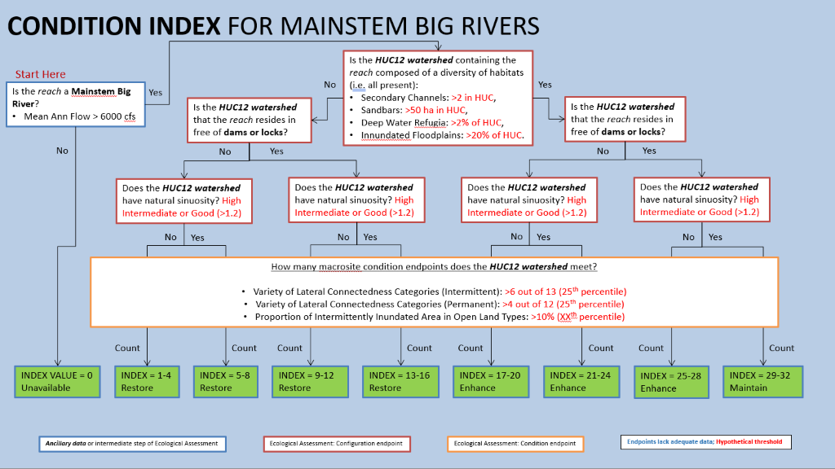

Figure 1. Decision and Scoring Framework for the Big Rivers Condition Index

## **What data are being used to evaluate the watershed indicators? What metrics were developed for the indicators?**

The Big Rivers Condition Index uses the medium resolution National Hydrography Dataset for identifying the stream and river segments and the Watershed Boundary Dataset for the 12-digit HUC watersheds. It analyzes conditions within the watersheds using six datasets:

* **SE Inundation Frequency** https://gcpolcc.databasin.org/datasets/0d0c5fb9d42f45d3a0a23872eda23543/
* **SE Floodplain Connectivity** https://gcpolcc.databasin.org/maps/030c4e0d39324be687a9738f092c3731/
* **National Inventory of Dams**  https://www.arcgis.com/home/item.html?id=eb00145cf8af416babe7b6a7458f7966
* **National Land Cover Data 2016**  https://www.mrlc.gov/national-land-cover-database-nlcd-2016
* **NHDPlus V2**  https://www.epa.gov/waterdata/nhdplus-national-hydrography-dataset-plus
* **NA River Width Dataset** http://gaia.geosci.unc.edu/NARWidth/

Further details on the datasets and how they were used can be found in Table 1.

Table 1. Datasets used to evaluate watersheds for aquatic habitat condition.

|  |  |  |  |  |
| --- | --- | --- | --- | --- |
| Indicator/Component | Type | Scale | Target/Metric | Source |
| Habitat Diversity (Sandbars, Secondary Channels, Deep Water Refugia, Seasonally-inundated floodplains) | Configuration | HUC12 | Presence of all | GCPO Inundation Frequency; GCPO Floodplain Connectivity |
| Linear Connectivity | Configuration | HUC12 | No barriers to movement | National Inventory of Dams |
| Lateral Connectedness - Intermittent h2o | Condition | HUC12 | >8 of 13 categories present | GCPO Inundation Frequency |
| Lateral Connectedness - Inundated open land | Condition | HUC12 | >7% of inundated area in HUC12 | GCPO Inundation Frequency and NLCD 2011 |
| Lateral Connectedness - Permanent h2o | Condition | HUC12 | >5 of 12 categories present | GCPO Inundation Frequency |
| Sinuosity | Condition | HUC12 | Good (>1.2) | NHDPlus V2 and NA River Width Dataset. |

## **What does the final output look like?**

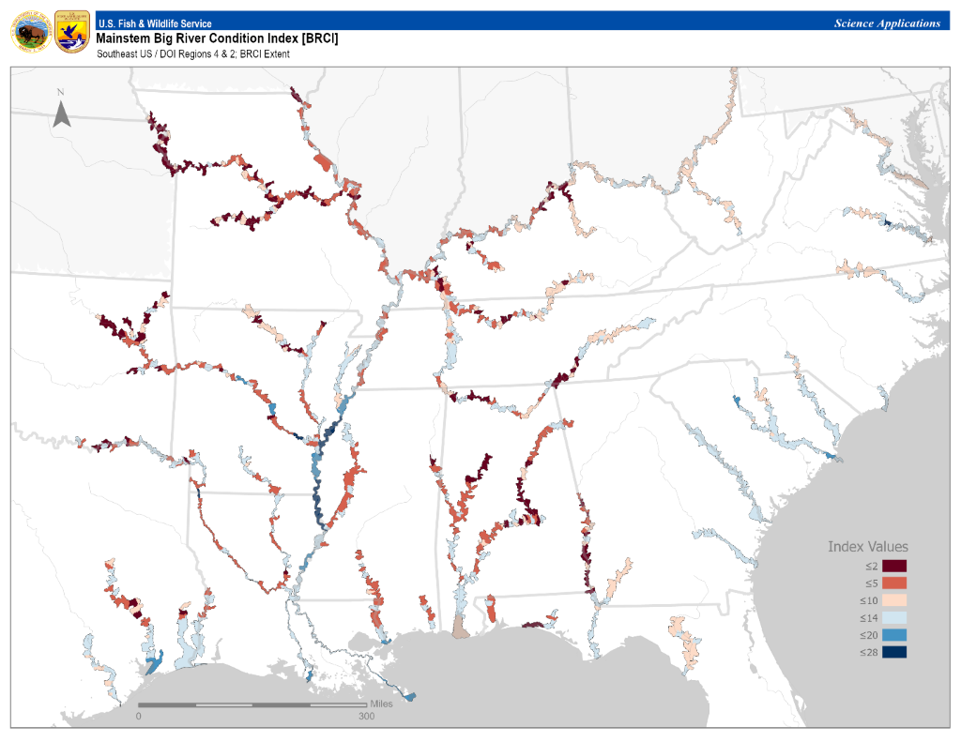

The final output is a spatial dataset that classifies HUC-12 watersheds based on their index score of unavailable, restore, enhance, or maintain.

## **Caveats?**

* Holes in the input dataset
* Metrics not included in the index

## **How is this tool being used? How can this tool be used?**

The tool is being incorporated into the 2021 Middle Southeast Blueprint update. It will help guide development of the overall Southeast Blueprint. The goal of Southeast Blueprint is a connected network of lands and waters throughout the southeast which supports thriving fish and wildlife populations and improved quality of life for the people in the geography. This tool will help in identifying the connected network.

This tool was developed to help support management decisions as well. The tool can help prioritize resources (funding, personnel, etc.) depending on the management action desired- watershed restoration, enhancement, or maintenance. Further, it can help identify larger regions which have potential to support aquatic species restoration efforts in the future, ex: SCGN recovery efforts. It can also be used in conjunction with the Streams and Rivers condition Index for a full picture of aquatic resources in the region.

## **Where does the Big Rivers Condition Index fit in the 2021 Middle Southeast Blueprint?**

Filed Under: Mid Southeast BP Update> Aquatics > Habitat > Big Rivers Condition Index